**Website for Desktop/Mobile App Performance Evaluation**

Hussein Nazif Ar Rifai

UTM MJIIT  
likes to play games, watch movies, collecting cards, and hanging out

**ABSTRACT**

This case study will provide more information based on responses from the users of Steam and Epic Games Store. This study explores what gamers think about the Steam and Epic Games Store apps. The platform that will be used for the survey is google form where it can find out how people feel about both apps and also SUS to calculate the response from the survey. Gamers can share their thoughts on which platform is more convenient in terms of efficiency.

Keyword : Steam, epic Games, SUS, Google Form, Analyse

# INTRODUCTION

In the world of gaming, the word Steam and Epic Games Store is not a foreign thing for most people. These two platforms is to be considered the biggest gaming platform for all people who want to play games on their device. Steam has been around for a long time and is known for having a huge selection of games and a strong community where players can talk and share tips. It has features like forums, user reviews, and lots of sales that make it a favourite for many gamers.

On the other hand, the Epic Games Store is newer and has been making a splash by offering exclusive games that you can’t find anywhere else. They often have free games and special promotions that attract lots of players. The aim of this case study is to find out what users like and dislike about both platforms. It seeks to understand why gamers choose one over the other. The motivation is to help both platforms improve and enhance the gaming experience for everyone. A key finding so far is that many players appreciate Steam for the convenience than Epic Games Store

# METHODOLOGY

The survey was conducted through google form and calculated in SUS score where it can show whole analysis of the survey. In google form the user will be asked 10 questions about the feedback and preferences for each Steam and Epic Games respectively. The users must fill the linear representative of the statement which are Strongly Disagree which is raw number 1 all the way to raw number 5 which is Strongly Agree. Once the survey got enough responses, the data will be put into SUS in raw data. Once the raw data is finished it will then be calculated in SUS score where the full analysis shown.

# RESULT AND DISCUSSION

There are 20 questions that is asked in the survey which are 10 for Steam and 10 for Epic Games Store. The format would be 2 same questions asking about Steam and Epic Games and it will be counted as 1 question. From the analysis shown the SUS score from Steam is getting excellent score meanwhile epic game are also doing good, another sample size shows that Steam is peaking with almost 100% response following by epic games with almost 95% response. Steam ended the analysis with the highest SUS score and value. The questions asked are the following.

Question 1:

* I think that I would like to use Steam frequently.
* I think that I would like to use Epic Games frequently.

Question 2:

* I found Steam unnecessarily complex.
* I found Epic Games unnecessarily complex.

Question 3:

* I thought Steam was easy to use.
* I thought Epic Games was easy to use.

Question 4:

* I think that I would need the support of a technical person to be able to use Steam.
* I think that I would need the support of a technical person to be able to use Epic Games.

Question 5:

* I found the various functions in Steam were well integrated.
* I found the various functions in Epic Games were well integrated.

Question 6:

* I thought there was too much inconsistency in Steam.
* I thought there was too much inconsistency in Epic Games.

Question 7:

* I would imagine that most people would learn to use Steam very quickly.
* I would imagine that most people would learn to use Epic Games very quickly.

Question 8:

* I found Steam very cumbersome to use.
* I found Epic Games very cumbersome to use.

Question 9:

* I felt very confident using Steam.
* I felt very confident using Epic Games.

Question 10:

* I needed to learn a lot of things before I could get going with Steam.
* I needed to learn a lot of things before I could get going with Epic Games.



**Fig 1:** Data recorded from google form.



**Fig 2:** raw data that was input to the SUS. Most users use both Steam and Epic Games but there are some difference in convenience and efficiency throughout the survey.

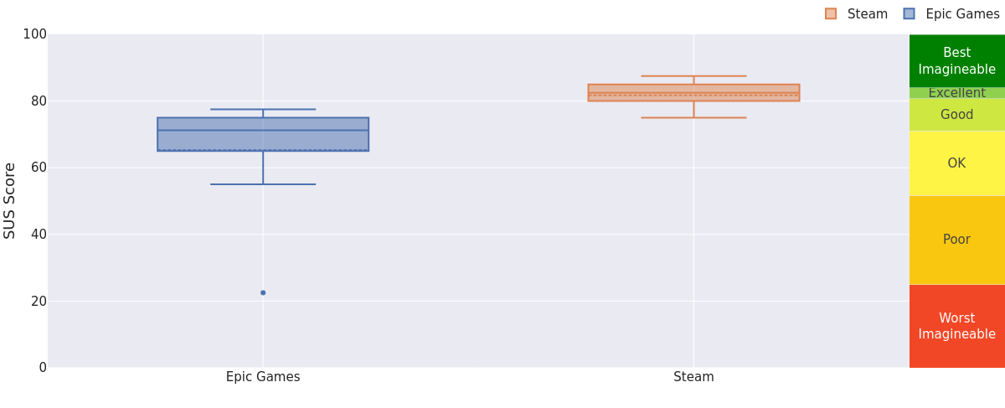

**Fig 3:** After finished analysing the data, Steam has excellent SUS score whereas Epic Games has good SUS score. This shows that Steam is more preferable for users because of its convenience and efficiency. Meanwhile epic games is not getting an excellent score also, it still shows that user are having good experience with the app because the data shows that epic games is not getting below ok score.

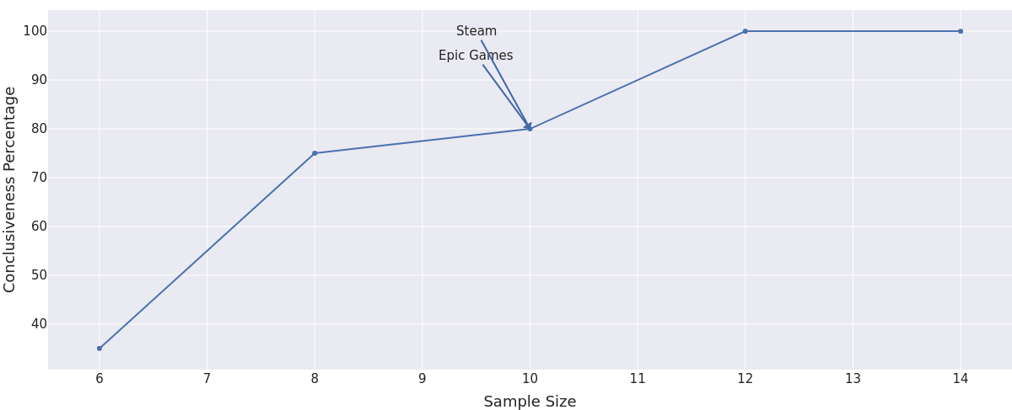

**Fig 4:** Steam peaking throughout 10 sample

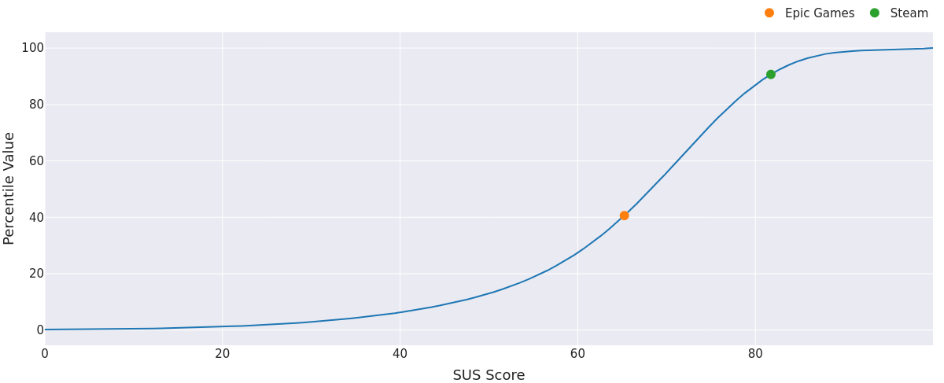

**Fig 5:** Steam getting the highest SUS score and value

# Conclusion

The conclusion of this case study is users are using both Steam and Epic Games app for their daily gaming use, but some user have different experience in navigating through the app. As the survey concluded, it’s clearly shown that Steam is more preferable in terms of UI navigation meanwhile some of the users don’t like the Epic Games UI. This means, Steam is better for users because of it’s convenient and efficiency meanwhile Epic Games has mixed review for its convenience. Both app is good for gaming but one has the advantage over the other like some user experienced, but regardless both Steam and Epic Games certainly can be used for gaming.

# REFERENCES

[1] <https://stuart-cunningham.github.io/sus/>

[2] <https://sus.mixality.de/>

[3] <https://store.steampowered.com/>

[4] <https://store.epicgames.com/en-US/>

[5] <https://www.movavi.com/learning-portal/steam-vs-epic-games.html>

[6] <https://www.trustedreviews.com/versus/steam-vs-epic-games-store-4318282>

[7] <https://www.pcmag.com/comparisons/steam-vs-epic-games-store-which-pc-game-store-deserves-your-dollars>

[8] <https://www.youtube.com/watch?v=TOSyRDoFLvQ>

[9]<https://www.reddit.com/r/Steam/comments/17h2oym/why_do_you_prefer_steam_to_epicgames_or_others/>

[10]<https://www.reddit.com/r/EpicGamesPC/comments/146apoq/epic_or_steam/>